Debugging Malloc Lab
Student ID _____________________
Student Name _____________________
Start Time ________________________
Finish Time ________________________

In this assignment, you will write a wrapper for the malloc package that will catch errors in the code that calls malloc and free. The skills you will have learned upon the completion of this exercise are pointer arithmetic and a greater understanding of the consequences of subtle memory mistakes.

Submit your source code: debugmalloc.c file and screen shot for each test case.

- Test case #1 [ screen shot]

- Test case #2 [ screen shot]

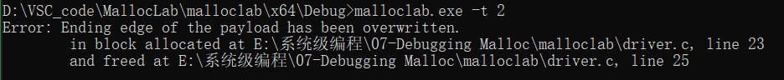

- Test case #3 [ screen shot]

- Test case #4 [ screen shot]

- Test case #5 [ screen shot]

- Test case #6 [ screen shot]

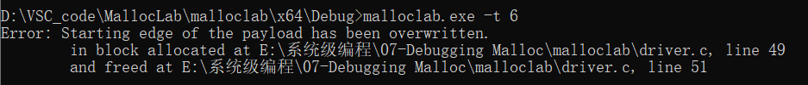

- Test case #7 [ screen shot]

- Test case #8 optional [ screen shot]

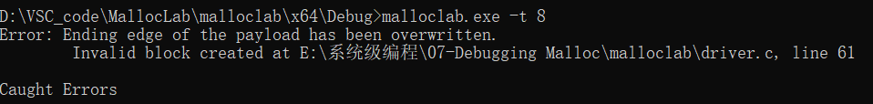

//参考资料：
//https://blog.csdn.net/junnda/article/details/123551523
//https://bbs.csdn.net/topics/390243289
//https://www.cnblogs.com/chunzhulovefeiyue/p/7885489.html

